**Communication system between two 89C51 microcontrollers**

**Introduction:**

Communication between two microcontrollers is very important in digital systems.In our daily life we have many things we contain two or more controllers and we have to communicate every controller to each other in order to run device properly.Similarly in industrial environment we have the site area on which machinesa and actual work is going on and we want to show the progress of the work on the remote site then we have to use methods to commmunicate between two controllers via show wireless method like blutooth, wifi ,zigbee and other things.This project mainly focuses on the communication of two AT89C51 controllers and there cooresponding result is shown on the 7 segment display and Leds.

**Circuit Diagram:**

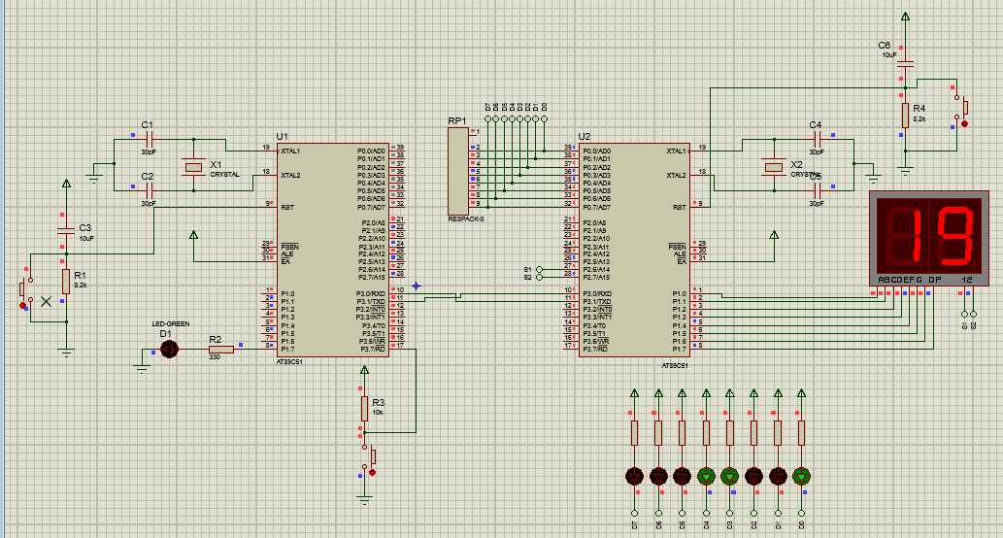

The circuit diagram contains the two AT89C51 microcontrollers, one 7 digit seven segment display, 8leds for showing the bcd code of the lst digit of student ID ,buttons and in the last but not least the basic comonents like capscitor ,resistor ,crystal oscillator for the proper working of the controllers. The circuit diagram is made on the proteus software and its simulation is also shown on this software.

**Working of Project:**

Button for input

Status Led

A89C51

At89C51

The block diaram shows the overall working of the project. In the beginning we will presss button upto the last digit value of student ID. In our case we wil press it

9 times and then the controller 1 will takes this value and transmit it to the controller 2 via its TRx pin.2nd controller will receive it via its Rx pin and show the last two digit of the ID on the 2 digit 7 segment display and also on 8 leds in the form of bcd code.In our case the number is 19 and bcd code for 19 is 00011001 and it is shown on the leds.after that his controller sends a byte to the controller 1 via its TRx pin and controller 1 receive it via RX line and flicker Led attached to it according its value.The main concept which is applied in this project for showing 2 digits on the seven segments is the multiplexing.To control two 7 segments 1st we turn on 1st segment via its S1 pin and show data on that then we turn off that on the S2 segment and show data on that.And this workis done so fast that we see that both are happening parallel.This concept of multiplexing is done every where the 7 segments are used like in shops,for decoration pieces and in electrnic gadgets.

**Main Code Part for Controller A:**

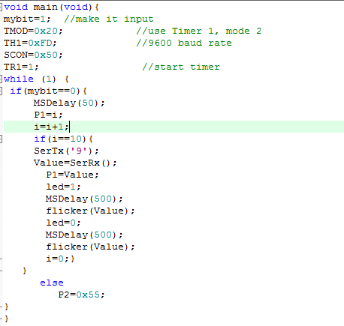

**Code explanation:**

A variable name as i is declared and the pin on which button is attached is declared as input.Then the process starts and user starts pressing button and i value starts increasing and when this value becomes equal to the predefined value it send this value to other controller via Tx line and then comes in the Rx mode. And when the 2nd controller sends value, it receives and flicker the led according to the received value.This is the main code of the first controller and the functions of this code are not shown here.

**Main Code Part for Controller B:**

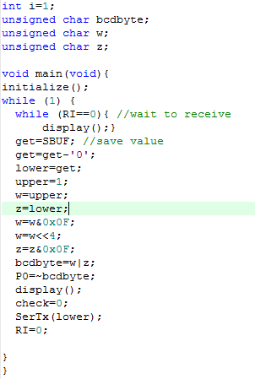

**Code explanation:**

In the starting the initialization is done for the Tx and Rx.In the beginning the controller takes the value from its Rx line and after that the controller shows the last digits of the student ID on the 2 digit 7 segment display. In parallel, the controller changes the both number of the id to BCD and show them on the 8 leds and after this the controller sends a byte via Tx line to the controller A and then comes in the Rx mode.In this part the multiplexing is done to showthe digitd on the 7 segment display and this 7segment display is atached on the PORT1 of the controller.And the 2 pins attached on P2.6 and P2.7 are controlling two segments.And these segments are given the name as S1 and S2 in the code.

**Conclusion:**

In last, we can say that the serial communication can be done between two controllers via the Tx and Rx lines but we should be take care that the baud rates of the both controllers should be same. In our project we have used the baud rates for both controllers is 9600 and the crystal frequency for the controllers is taken as 11.059MHz. Baud rate syncronization is the 1st and foremost condition for the communiction between two microcontrollers.This project can be used in every device which contains controllers more than one and its industrial usgae is also very important.